Accommodation Information and

Recommendations

Please see below some of our recommendations for accommodation around Oxford. Please do let us know if you would like any further information regarding any of these venues.

**Oxford Colleges**

Oxford University Colleges have B&B and self-catering bedrooms available. Most colleges are within a 15 minute walk from the Saïd Business School.

To check availability and prices, please visit: [**http://www.universityrooms.com**](http://www.universityrooms.com)

**Macdonald Randolph Hotel**

The Macdonald Randolph Hotel is a 5-star hotel based in Oxford City Centre. It is approximately a 10 minute walk from the Saïd Business School.

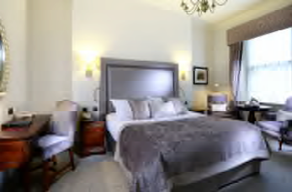For availability and prices please contact the hotel using the details below:

Tel: **+44 (0)1865 256415**

E-Mail: [**sales.randolph@macdonald-hotels.co.uk**](mailto:sales.randolph@macdonald-hotels.co.uk)

Web: [**www.macdonaldhotels.co.uk/randolph**](http://www.macdonaldhotels.co.uk/randolph)

**Malmaison Hotel**

The Malmaison Hotel is a 4-star hotel based in Oxford City Centre. It is approximately a 5 minute walk from the Saïd Business School.

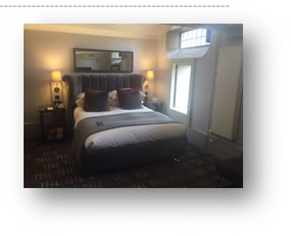

For availability and prices please contact the hotel using the details below:

Tel: **+44 (0)1865 268422**

E-Mail: [**eventsmgr.oxford@malmaison.com**](mailto:eventsmgr.oxford@malmaison.com)

Web: [**https://www.malmaison.com/locations/oxford**](https://www.malmaison.com/locations/oxford)

**Oxford Spires Hotel**

The Oxford Spires Hotel is a 4-star hotel based just outside of Oxford City Centre. It is approximately a 25 minute walk or a 5 minute drive from the Saïd Business School.

For availability and prices please contact the hotel using the details below:

Tel: **+44 (0)1865 324324**

E-Mail: [**oxfordspiresreservations@oxfordspireshotel.co.uk**](mailto:oxfordspiresreservations@oxfordspireshotel.co.uk)

Web: [**https://www.phcompany.com/principal/oxford-spires/**](https://www.phcompany.com/principal/oxford-spires/)

**Egrove Park**

Egrove Park is the second venue of the Saïd Business School based just outside Oxford, in Kennington. It is approximately a 50 minute walk or 10 minute drive from the main Saïd Business School.

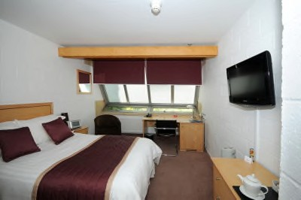For availability and prices please contact the hotel using the details below:

Tel: **+44 (0)1865 422600**

E-Mail: [**Egroveparkreception@sbs.ox.ac.uk**](mailto:Egroveparkreception@sbs.ox.ac.uk)

Web: [**https://www.booking.com/hotel/gb/egrove-park-university-of-oxford**](https://www.booking.com/hotel/gb/egrove-park-university-of-oxford)